**Hindi Vidya Prachar Samiti’s**

**Ramniranjan Jhunjhunwala College of Arts, Science & Commerce**

**(Empowered Autonomous College)**



**Affiliated to**

**UNIVERSITY OF MUMBAI**

**DEPARTMENT OF INFORMATION TECHNOLOGY**

**2025 - 2026**

**M.Sc. (IT) PART 2 - SEM IV**

**RJSPITE302P – Deep Learning**

**Name: Vishwakarma Shivam Suresh Sushila**

**Roll No: 6709**

**Hindi Vidya Prachar Samiti’s**

**Ramniranjan Jhunjhunwala College of Arts, Science & Commerce**

**(Empowered Autonomous College)**

***Certificate***



**This is to certify that Mr. Vishwakarma Shivam Suresh Suhila Roll No 6709 of M.Sc.(I.T.) Part-1 class has completed the required number of experiments in the subject of Deep Learning in the Department of Information Technology during the academic year 2025 - 2026 .**

**Professor In-Charge Co-ordinator of IT Department**

**Prof. Bharati Bhole Prof. Bharati Bhole**

**College Seal & Date Examiner**

### **INDEX**

|  |  |  |  |
| --- | --- | --- | --- |
| **Sr No.** | **Title** | **Date** | **Remarks** |
| 1 | Implement Matrix Multiplication, Eigen Vectors, Eigenvalue Computation Using Tensorflow. | Jul 17, 2025 |  |
| 2 | Implement Deep Feedforward Network For Xor Using Keras | Jul 17, 2025 |  |
| 3 | Implement Gradient-Descent Using Numpy | Jul 24, 2025 |  |
| 4 | Implement Image Recognition Using Mnist Dataset. | Jul 31, 2025 |  |
| 5 | Implement Backpropagation Using Pandas | Aug 14, 2025 |  |
| 6 | Implement Ensemble Learning Technique - Bagging, Decision Tree, Random Forest. | Sep 5, 2025 |  |
| 7 | Implement Regularization On Sonar Dataset Using Dropout Technique. | Sep 5, 2025 |  |
| 8 | Implement Image Classification On Cifar Dataset Using CNN | Sep 11, 2025 |  |
| 9 | Data Augmentation   1. Implement on a single image 2. Implement on a dataset | Sep 18, 2025  &  Sep 20, 2025 |  |
| 10 | Implement RNN (Recurrent Neural Network) | Sep 20, 2025 |  |

**All Practicals Google Colab file:**

<https://colab.research.google.com/drive/1IYsmU9_XAHEyjkbH4xWkrgsCb-4gbM_C#scrollTo=OC0rjIGdh98G>

### **Practical 1: Implement Matrix Multiplication, Eigen Vectors, Eigenvalue Computation Using Tensorflow.**

Jul 17, 2025

**Matrix multiplication** involves taking two matrices (rectangular arrays of numbers) and combining them to produce a new matrix. It is used in various applications, including transforming data, solving systems of linear equations, and in computer graphics.

**Eigenvectors** are special vectors that, when a matrix is applied to them, only get scaled (not rotated). They help in understanding the fundamental properties of matrices and are used in various fields like physics, statistics, and machine learning for tasks like dimensionality reduction.

**Eigenvalues** are the scaling factors associated with eigenvectors. They tell us how much the eigenvector is stretched or compressed. They give insights into the behavior of the matrix, such as its stability and the directions in which it stretches or compresses space.

**Step 1**: Import tensorflow library

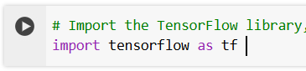

**Step 2**: Creating a matrix

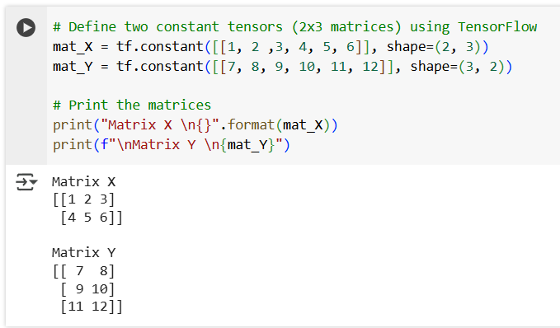

**Step 3**: Finding the product

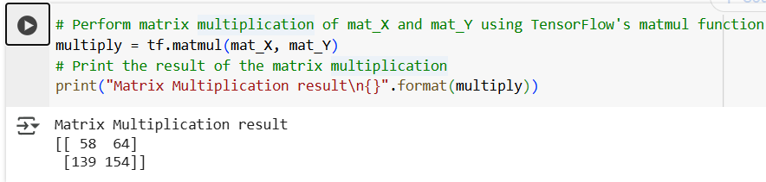

**Step 4**: Creating a random matrix to find eigenvalues and eigenvectors

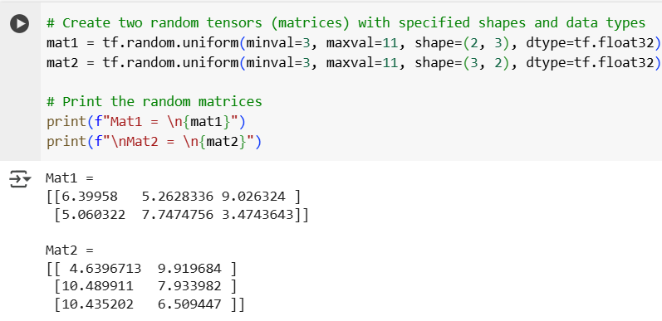

**Step 5**: Calculate the Eigenvectors and eigenvalues.

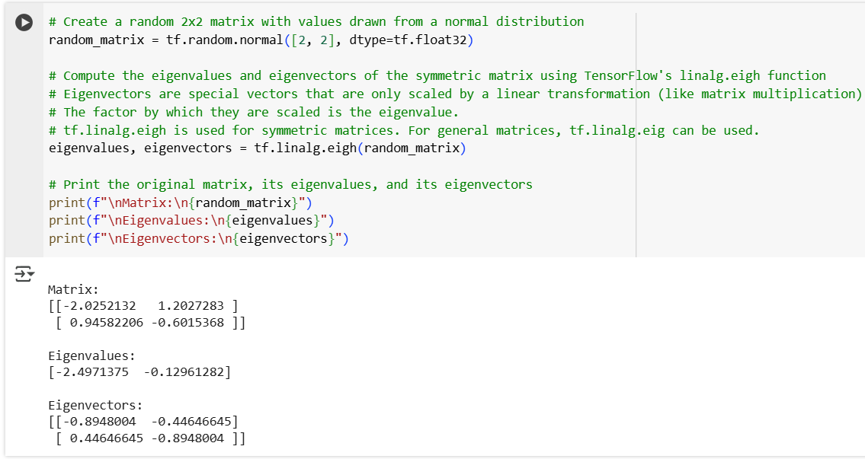

### **Practical 2: Implement Deep Feedforward Network For Xor Using Keras**

Jul 17, 2025

**FeedForward Network**: This is a type of artificial neural network where information moves in one direction—from input to output. There are no loops or cycles in the connections.

**Deep**: A network is considered deep if it has more than one hidden layer between the input and output layers. This allows it to learn more complex patterns.

A **Deep FeedForward Network** for **XOR** is essentially a tool to learn complex patterns that a simple model can't capture. By using multiple layers, it can effectively solve the XOR problem by learning to transform inputs into a form where the outputs (0 or 1) can be predicted accurately.

**Step 1**: Import libraries

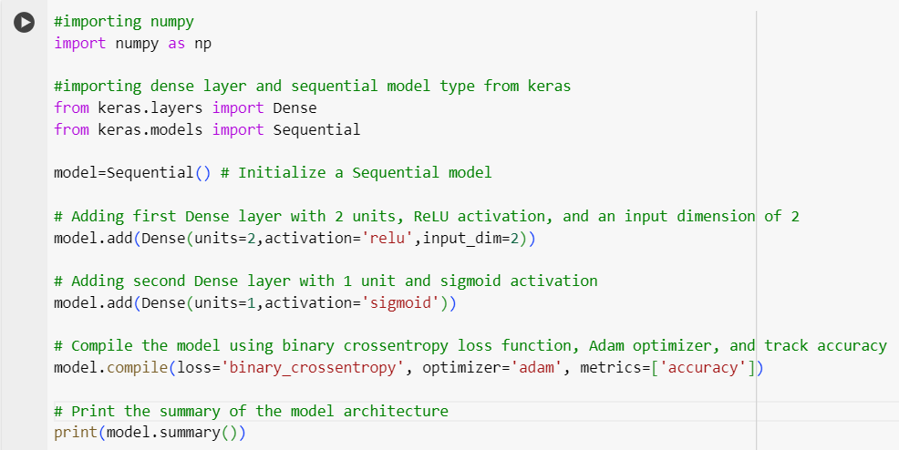

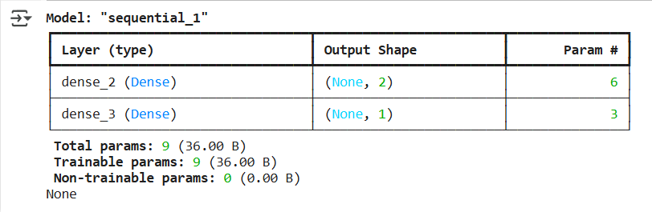

**Step 2**: Check the weights

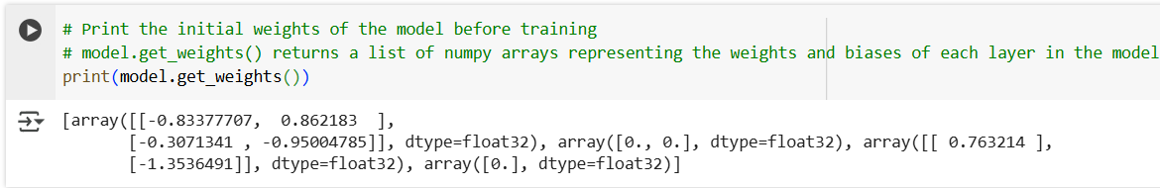

**Step 3**: Defining input data and training the model

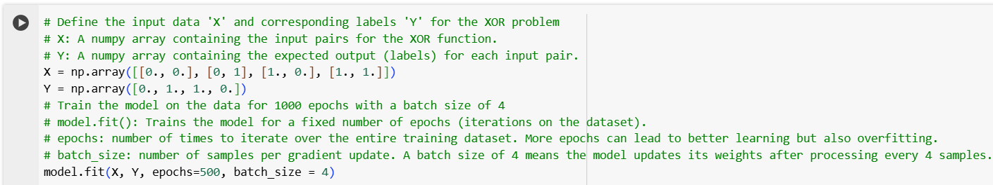

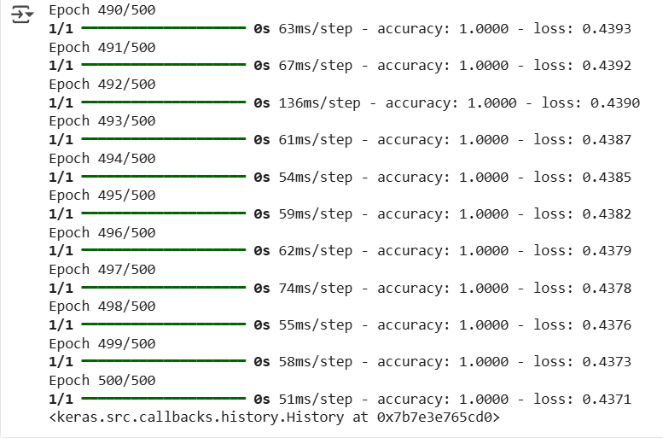

**Step 4**: Print

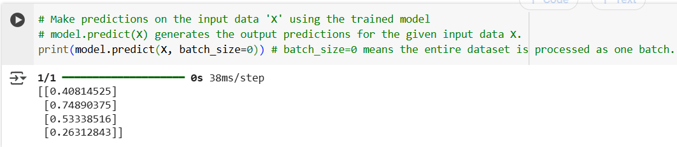

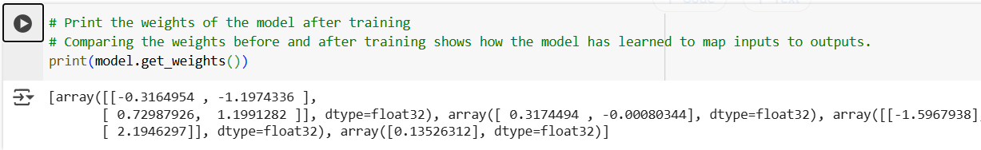

### **Practical 3: Implement Gradient-Descent Using Numpy**

Jul 24, 2025

**Gradient Descent** is an optimization technique used to find the best solution (like minimizing errors or costs) in machine learning and other mathematical problems. It is a method to find the best solution by repeatedly moving in the direction that reduces the function’s value. It’s like finding the lowest point on a hill by taking steps downhill, adjusting your path as you go. This technique is fundamental in training machine learning models, helping them to minimize errors and improve performance.

**Step 1:** Import numpy

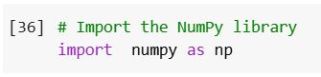

**Step2:** write the below code of gradient-descent

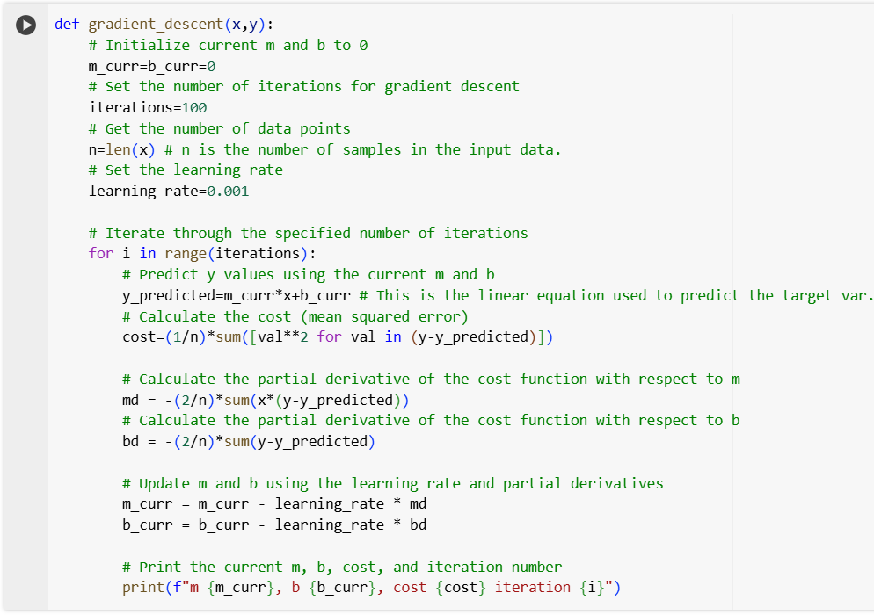

**Step 3:** Display the output.

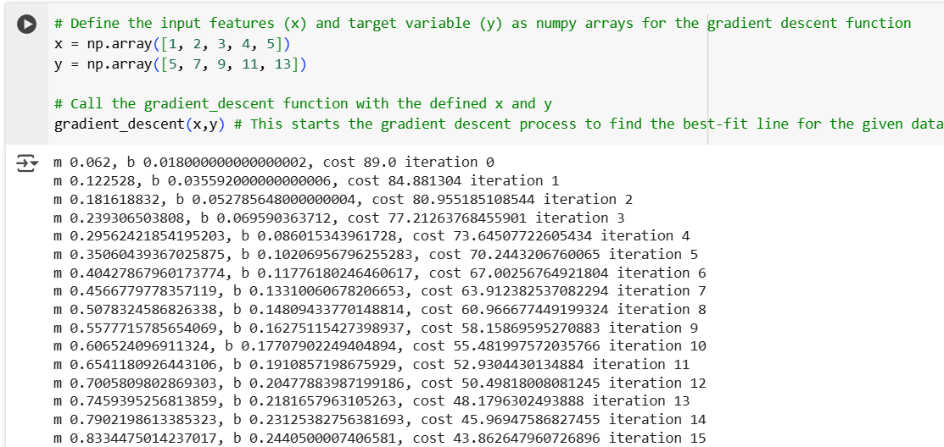

### **Practical 4: Implement Image Recognition Using Mnist Dataset.**

Jul 31, 2025

**Image recognition** in Deep Learning involves using advanced algorithms to identify objects or features in images. It uses neural networks to analyze and classify images. It works by extracting features from images through multiple layers, learning from labeled examples, and then applying this knowledge to identify objects or patterns in new images. This technology is used in various applications, such as facial recognition, autonomous vehicles, and medical imaging.

**Step 1**: Import the required libraries

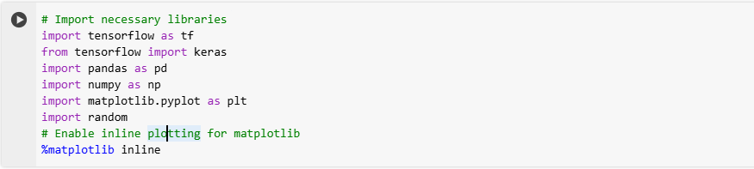

**Step 2**: Import mnist dataset.

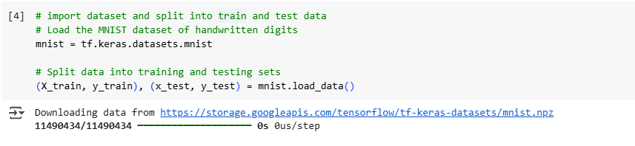

**Step 3**: Perform following analysis.

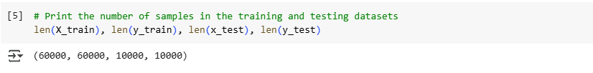

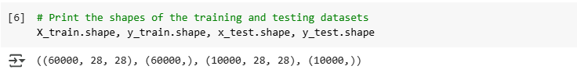

**Step 4**: Click on “Show Data”

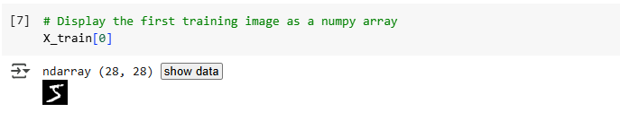

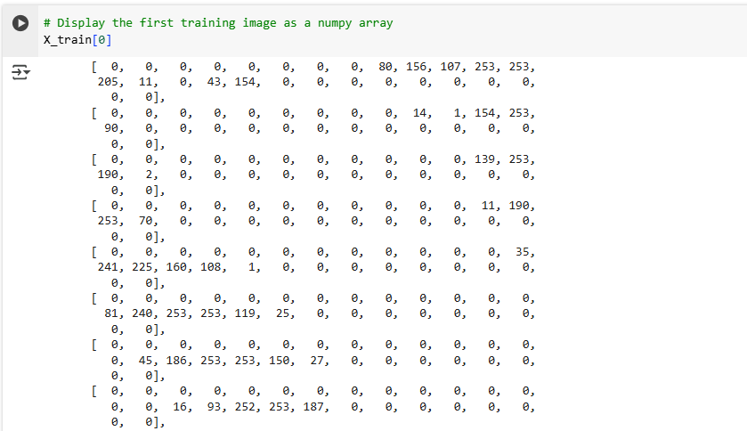

Image

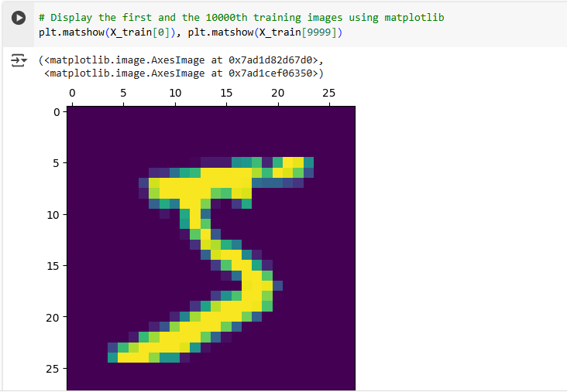

**Step 5**: Normalize

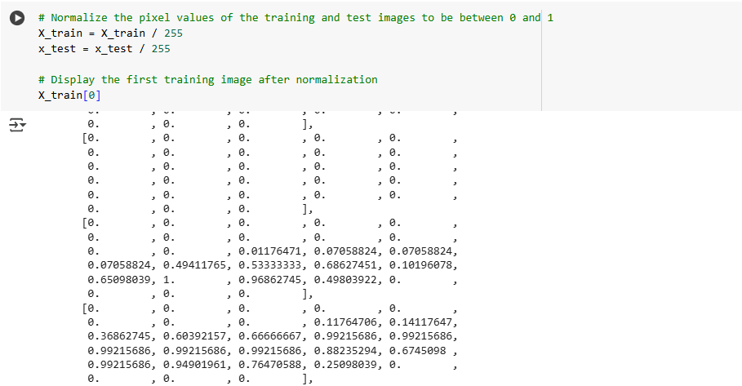

**Step 6:** Check the summary

(“Flatten” is used to convert 2D into 1D array)

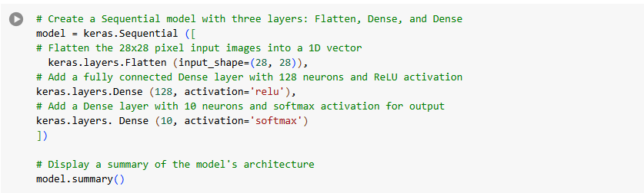

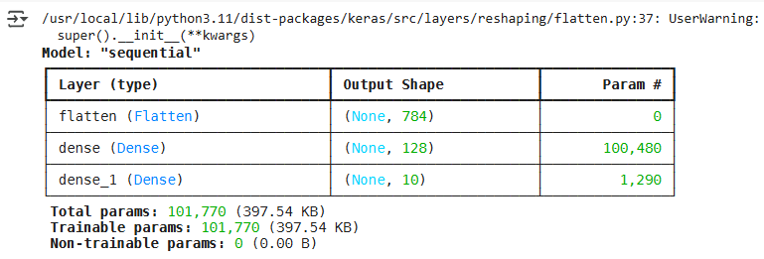

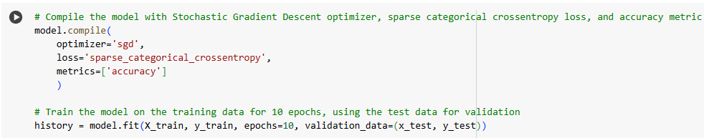

**Step 7:** History



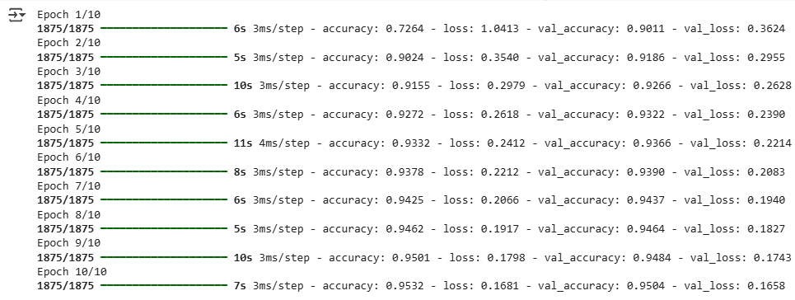

**Step 8:** Evaluate the model.

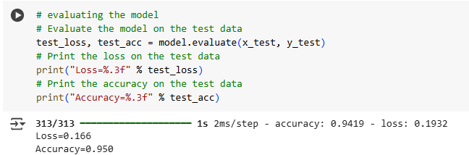

**Step 9**: Make a new prediction for new data

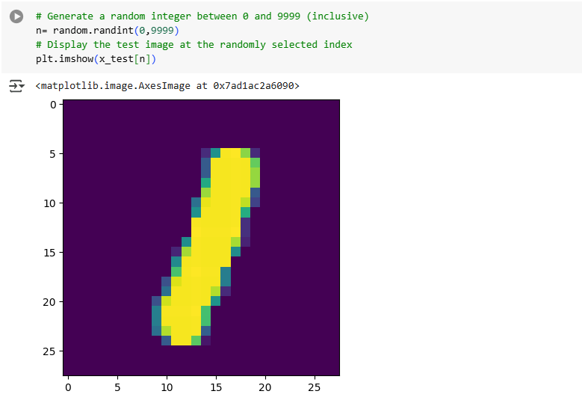

**Step 10:** To find thehandwritten data

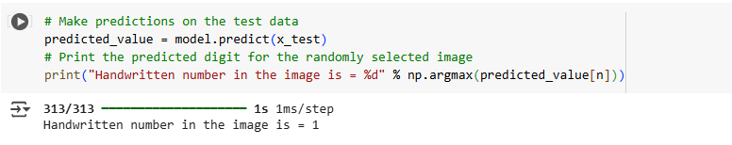

**Step 11**: Plot the graph for Accuracy and Loss

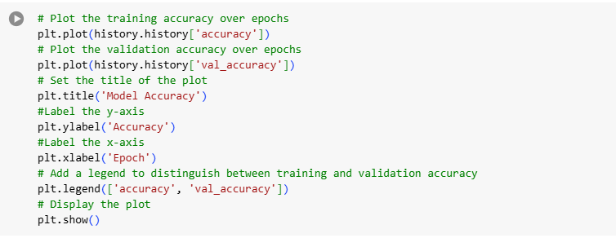

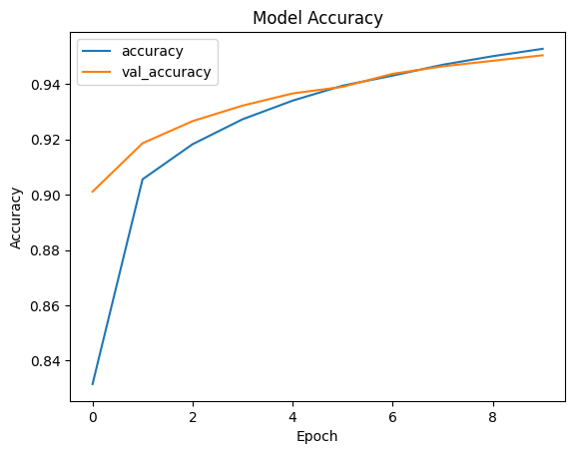

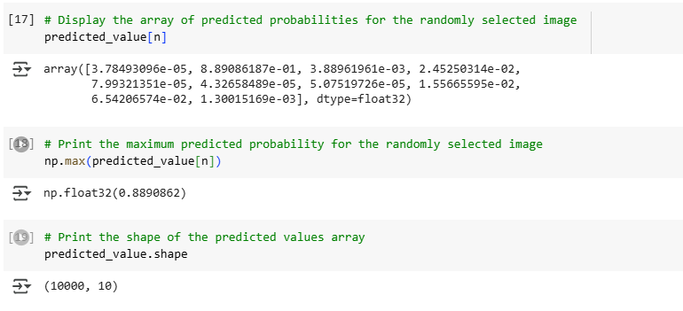

### **Practical 5: Implement Backpropagation Using Pandas**

Aug 14, 2025

**Backpropagation** is a key concept in training neural networks. The goal is to minimize the difference between the model’s predictions and the actual outcomes. This difference is called the "error" or "loss." It is a method for training neural networks by adjusting the weights to minimize errors through a process of forward and backward passes. This helps the network learn from its mistakes and improve over time.

**Step 1:** Import the Libraries



**Step 2:** Sigmoid Function

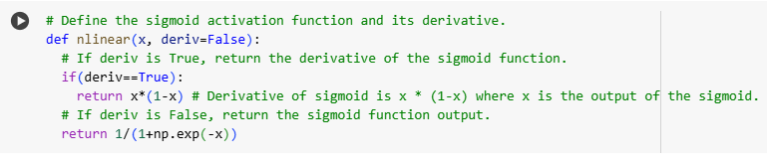

**Step 3:** Creating datasets

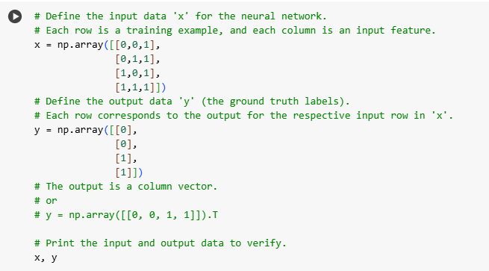

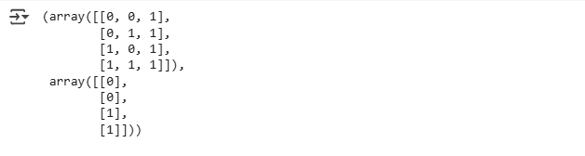

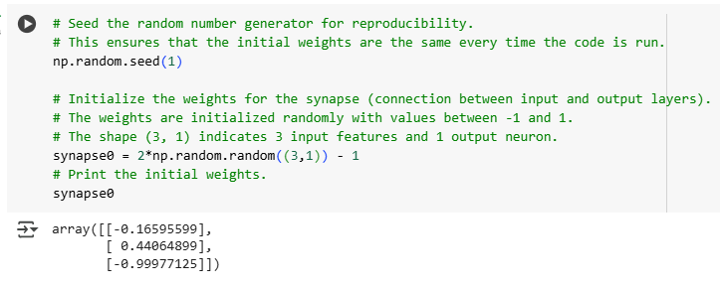

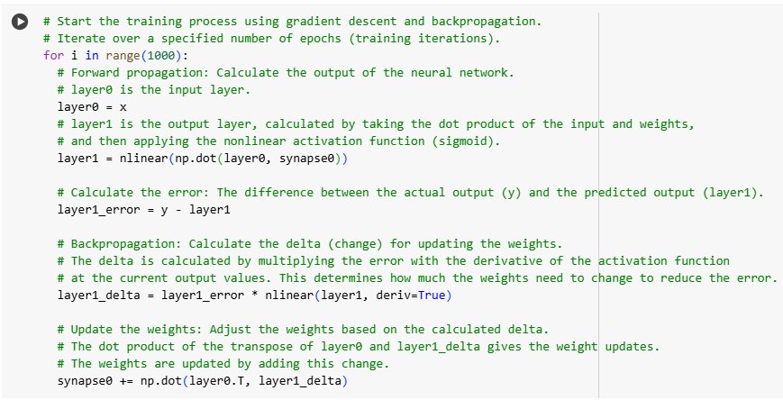

**Step 4:** Print the Output

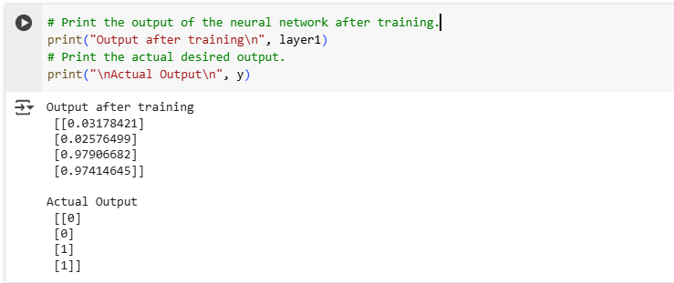

**Step 5:** Plot the Graph

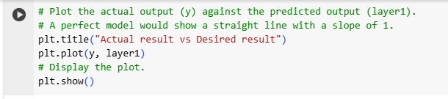

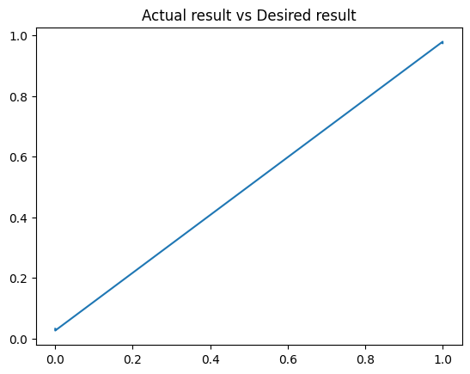

### **Practical 6: Implement Ensemble Learning Technique - Bagging, Decision Tree, Random Forest.**

Sep 5, 2025

Dataset link → <https://www.kaggle.com/datasets/uciml/pima-indians-diabetes-database?resource=download>

A **decision tree** is a flowchart-like structure used to make decisions or predictions. It splits the data into branches based on certain criteria until it reaches a decision or prediction. It is a single model that makes predictions based on a series of decision rules.

**Bagging** is an ensemble method that improves the accuracy and robustness of machine learning models by combining predictions from multiple models. It combines multiple models (e.g., decision trees) trained on different subsets of data to improve performance and stability.

**Random forest** is an extension of bagging specifically for decision trees. It builds multiple decision trees and combines their predictions to improve accuracy and control overfitting. It is a type of bagging that specifically uses multiple decision trees, each trained on random subsets of data and features, and combines their predictions for better accuracy.

**Step 1**: Import the pandas library to load and display the dataset

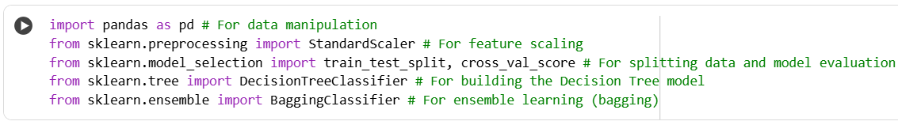

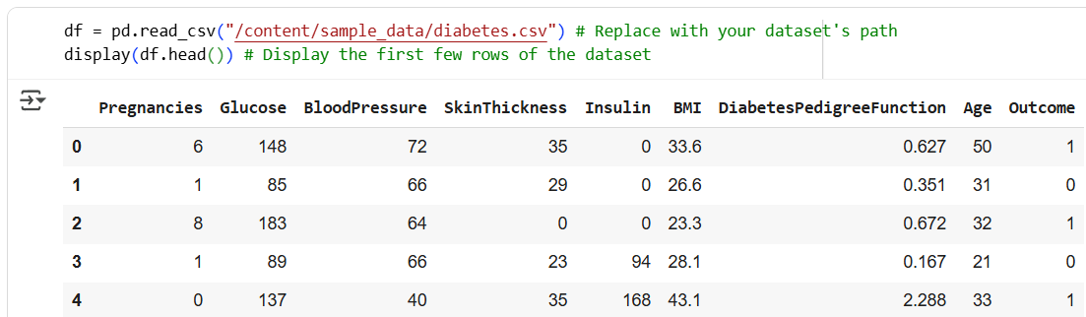

**Step 2:** Describe Dataset

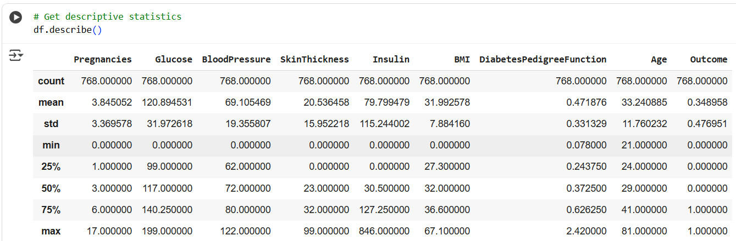

**Step 3**: Write the below code

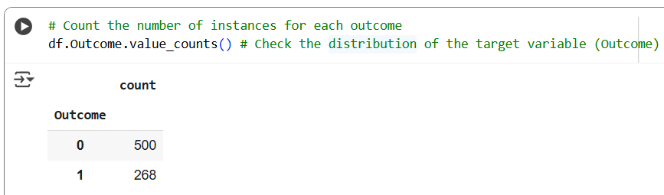

**Step 4**: Splitting the dataset into features and target

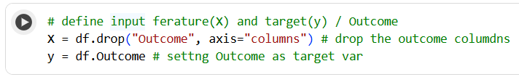

**Step 5**: Standardizing the features

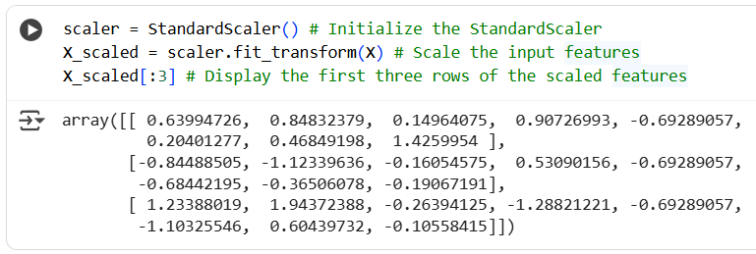

**Step 6**: Perform training and testing dataset

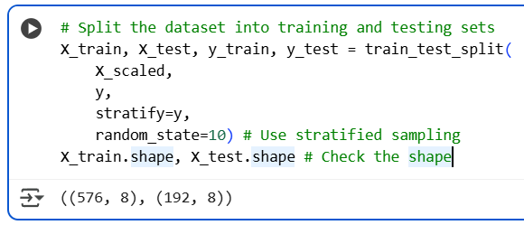

**Step 7**: Write the below code:

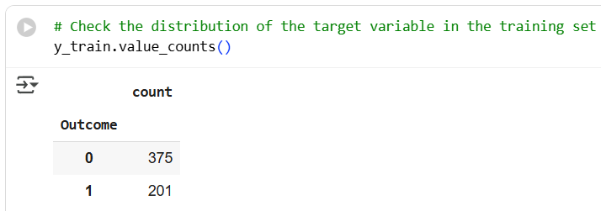

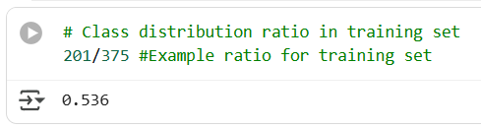

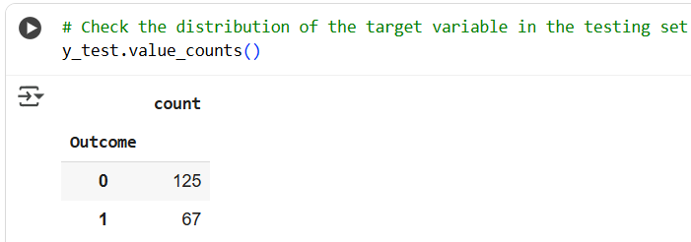

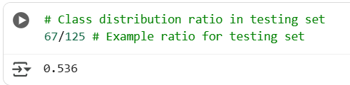

**Step 8**: Train using stand-alone model

A **"standalone model"** refers to a machine learning model that is used on its own, without any additional models or techniques combined with it

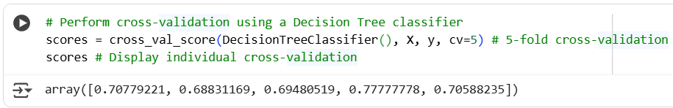

**Step 9**: Find out the mean of scores

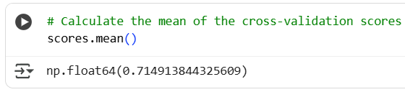

**Step 10**: Train using bagging

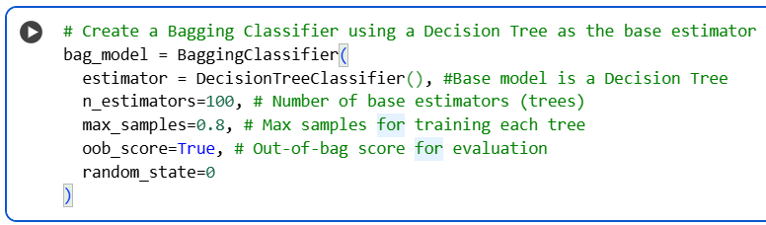

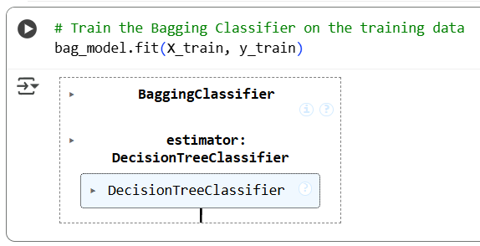

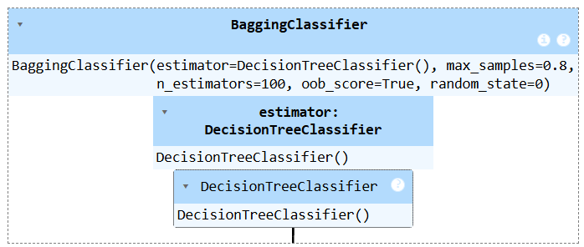

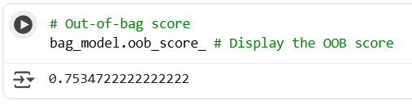

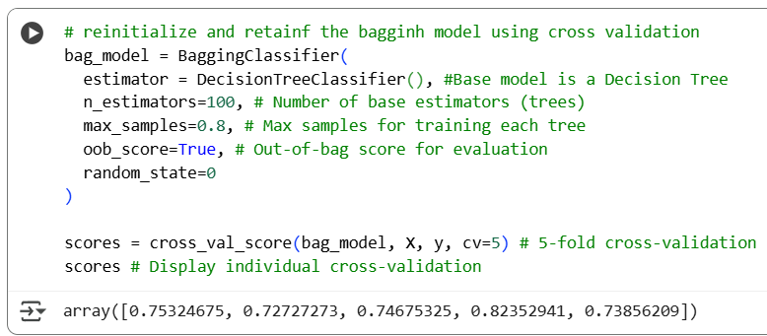

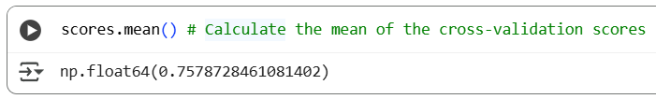

**Step 11**: Train using random forest model.

A **Random Forest** is an ensemble learning technique used for classification and regression tasks that operates by constructing a multitude of decision trees during training. It combines the predictions of these trees to produce a more accurate and robust output. The final prediction is made by aggregating the results from all the individual trees, typically using majority voting for classification or averaging for regression

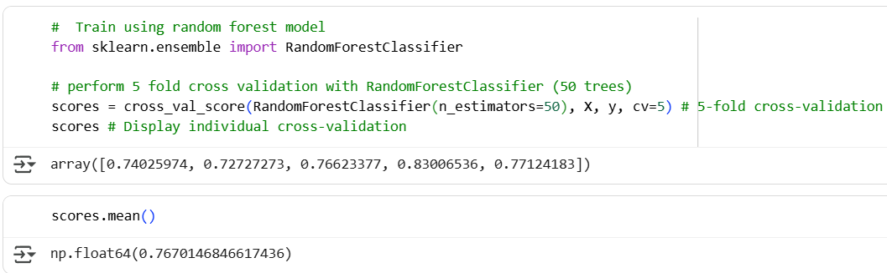

### 

### **Practical 7: Implement Regularization On Sonar Dataset Using Dropout Technique.**

Sep 5, 2025

Data set link →

<https://www.kaggle.com/datasets/rupakroy/sonarcsv>

Regularization is used to prevent overfitting, where a model becomes too complex and starts to capture noise in the training data instead of the underlying pattern. Dropout is one of the most popular regularization methods, particularly in the context of training deep neural networks.

**Dropout** is a regularization technique that involves randomly "dropping out" (i.e., setting to zero) a proportion of the neurons in a neural network during training. This prevents the network from becoming too dependent on any particular neuron, thereby encouraging it to learn more robust and generalizable features.

**Note: M and R means Mines and Rocks**

**Step 1**: Import the necessary libraries and load the dataset 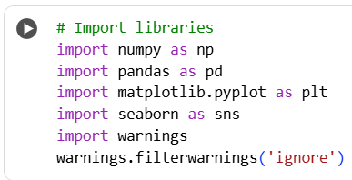

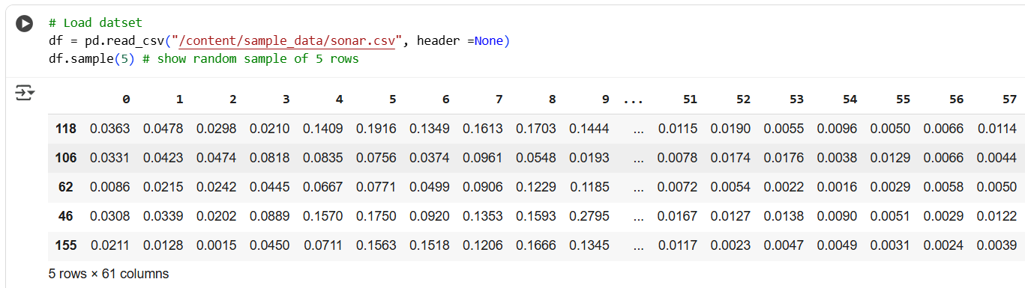

**Step 2:** Do the **analysis**

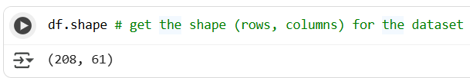

**Step 3**: Calculate the missing data

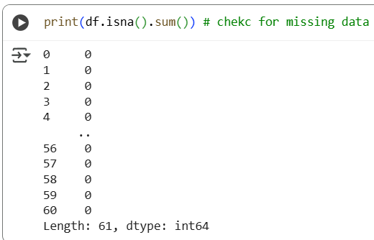

**Step 4**: Print the Columns names

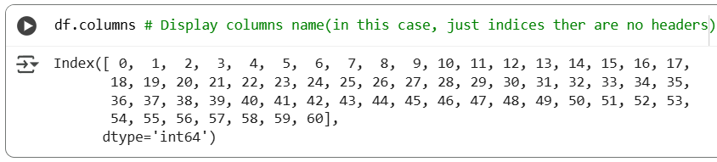

**Step 5**: Count Frequency of values

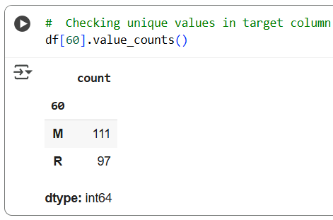

M and R means Mines and Rocks

**Step 6:** Create feature matrix and target variable

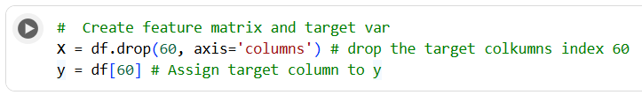

**Step 7**: Splitting the dataset into train and test ad checking shape

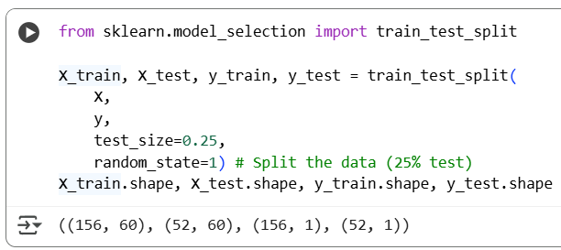

**Step 8** : Import libraries 🡪 Define, compile and train the model

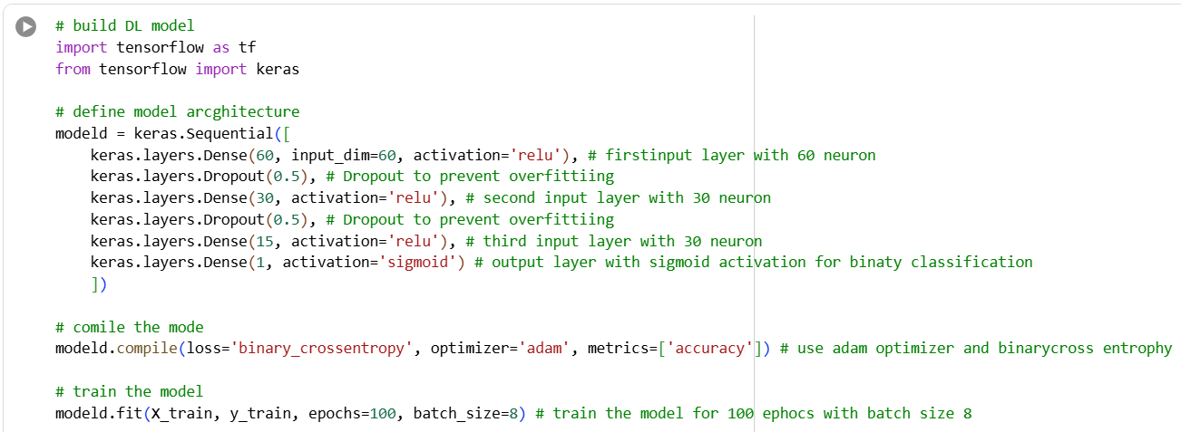

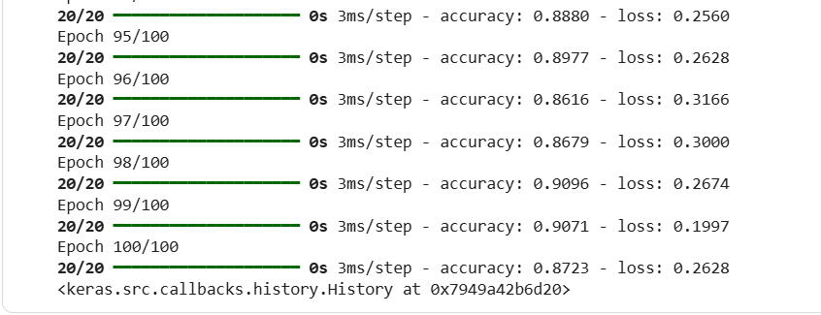

**Step 9**: Evaluate the model

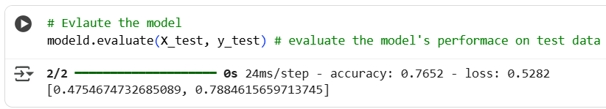

**Step 10**: Predict the output and display the binary values

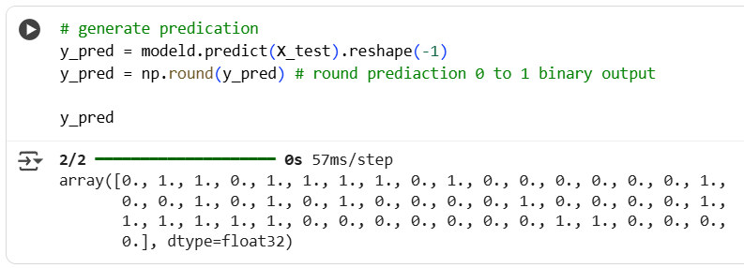

**Step 11**: Print the Classification report and confusion matrix

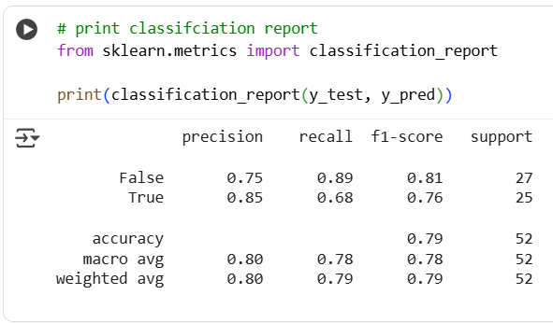

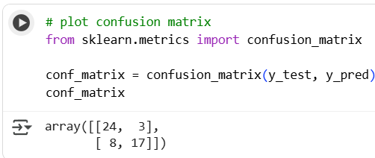

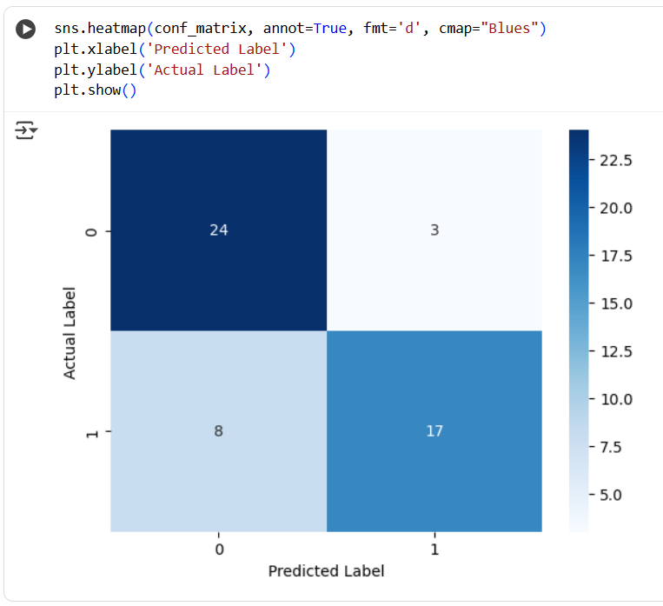

**Step 12:** trying without Dropout - it will overfit the model

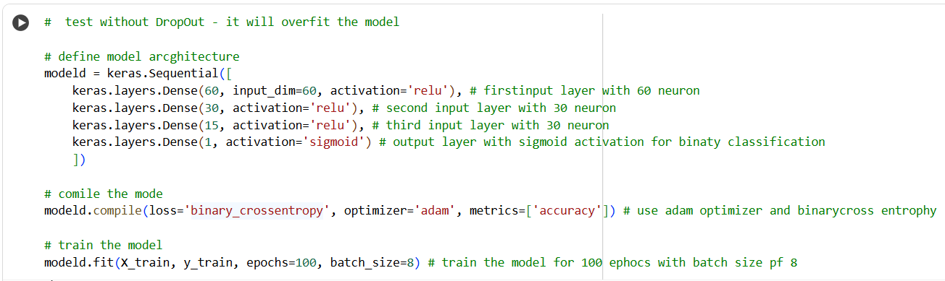

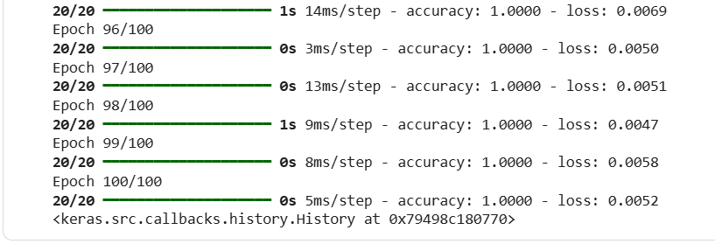

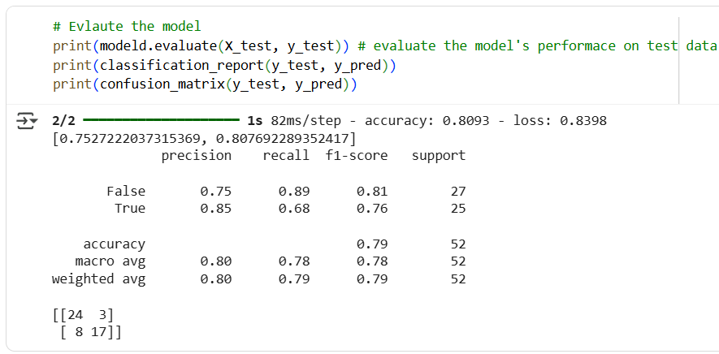

### **Practical 8: Implement Image Classification On Cifar Dataset Using CNN**

Sep 11, 2025

Data set →

<https://www.kaggle.com/c/cifar-10/>

Image classification using a Convolutional Neural Network (CNN) is a process where a computer model is trained to recognize and categorize images into different classes or labels.

Convolutional Neural Network (CNN) is a type of deep learning model specifically designed for working with images. Unlike traditional neural networks, CNNs can automatically detect and learn features from images, such as edges, textures, and patterns, through their layers.

**Step 1:** Import libraries and load dataset into train and test

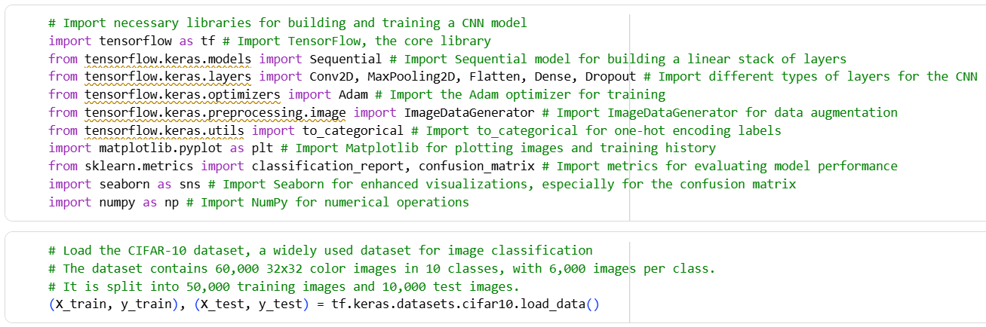

**Step 2:** Display the shape

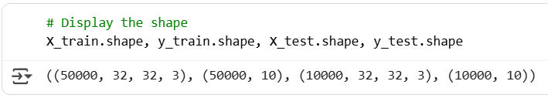

**Step 3:** Checking the Training name

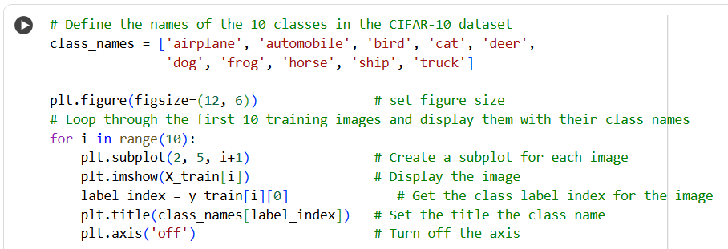

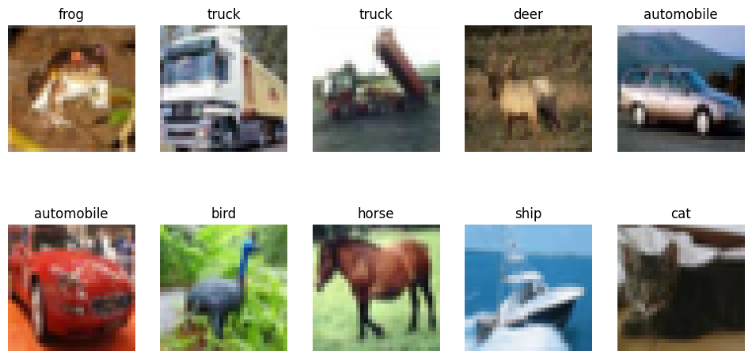

**Step 4:** Normalizing the training and test features

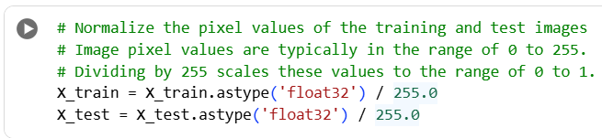

**Step 5:** Encoding the training and test targets

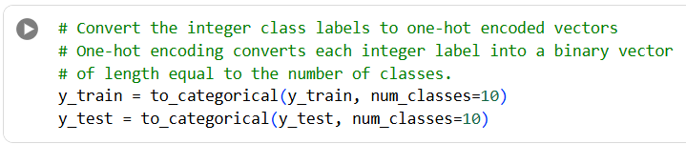

**Step 6:** Building the sequential model

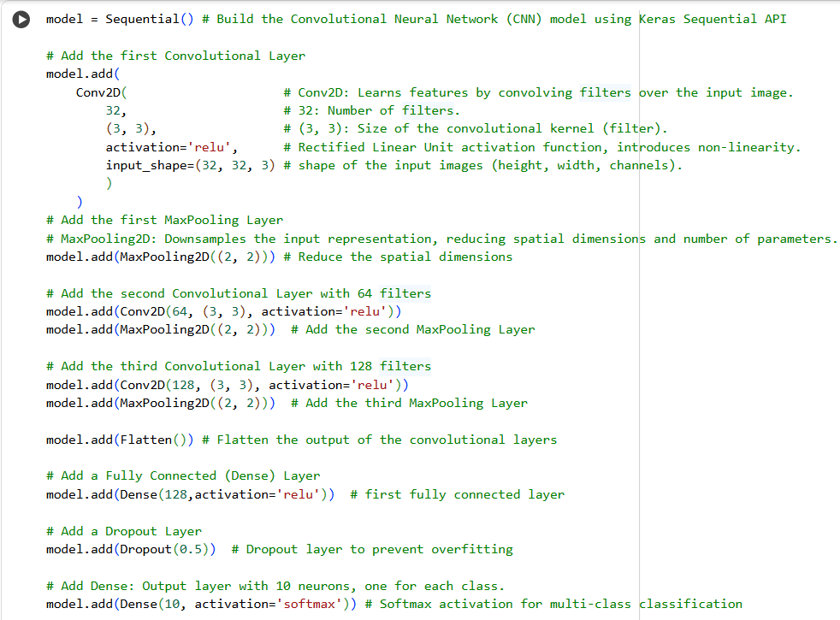

**Step 7:** Compiling the model

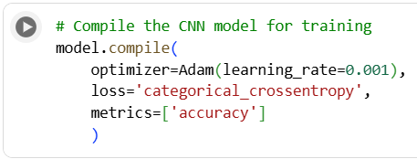

**Step 8:** Data augmentation

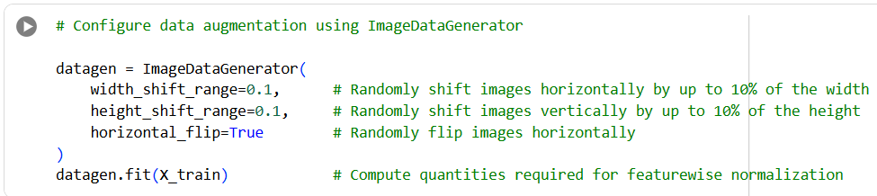

**Step 9:** Fitting the model

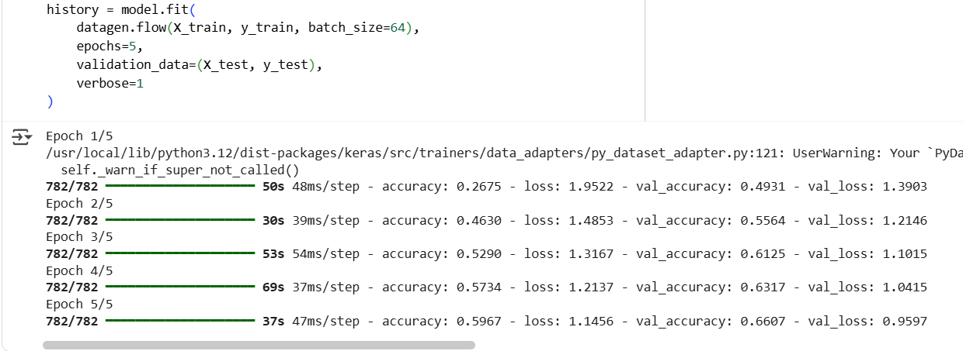

**Step 10:** Model Evaluation

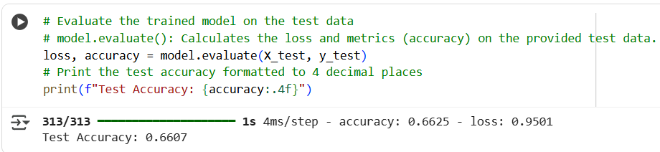

**Step 11:** Predication of test images and plot

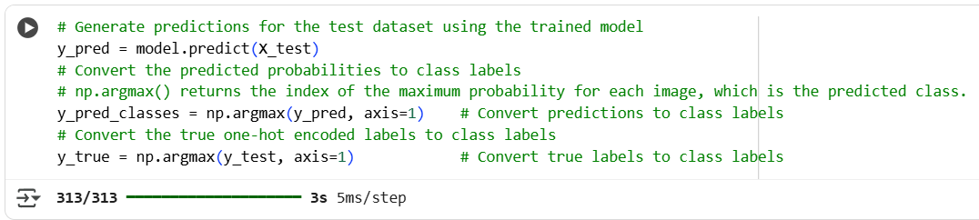

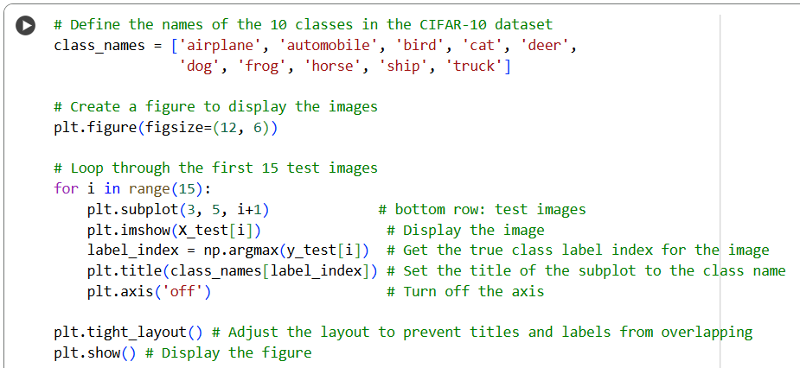

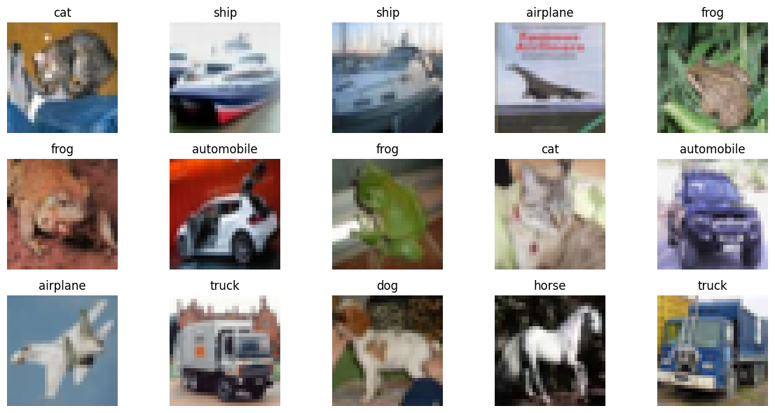

**Step 12:** Other plot and metrics

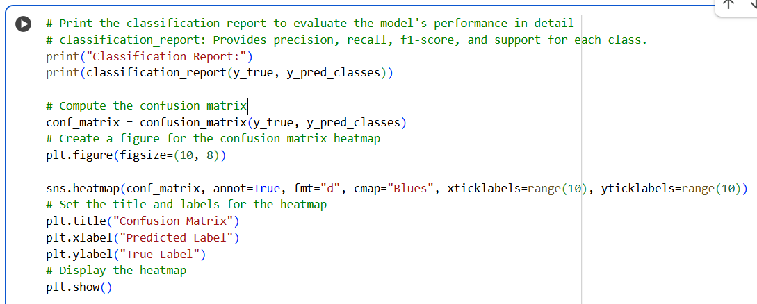

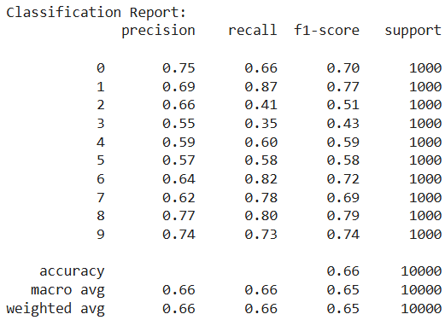

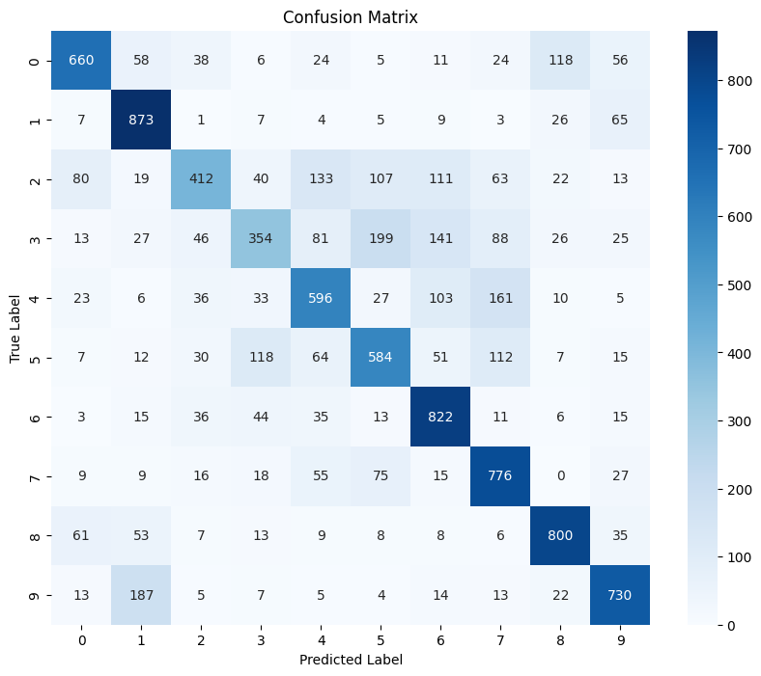

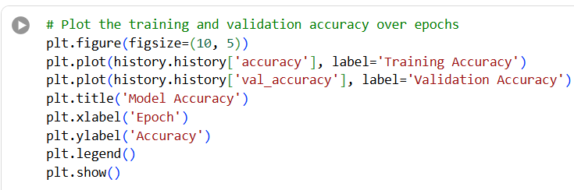

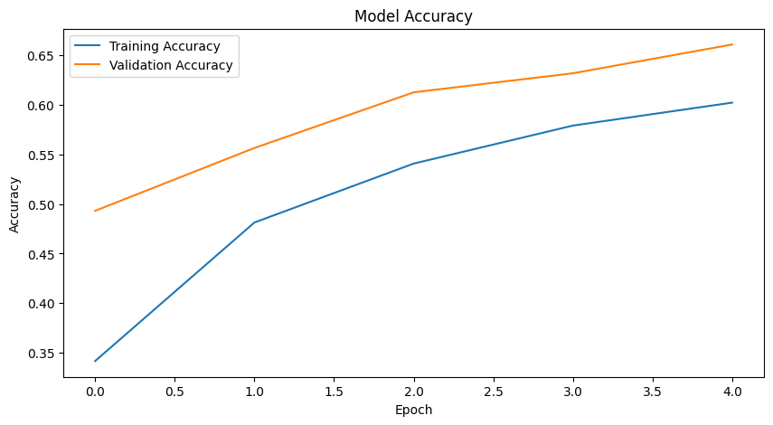

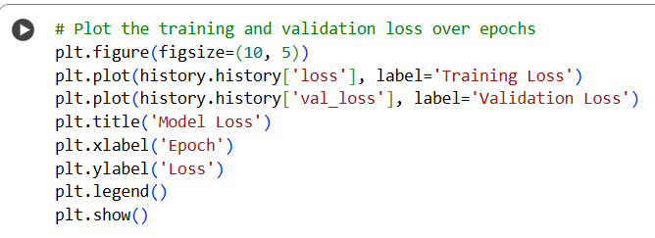

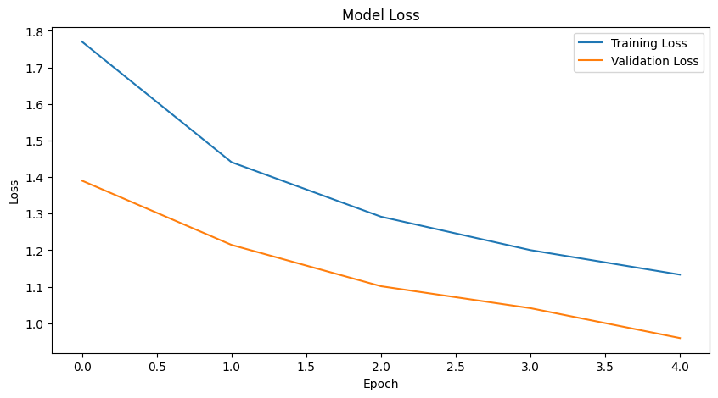

### **Practical 9: Data Augmentation**

**Dataset Link:** <https://storage.googleapis.com/download.tensorflow.org/example_images/flower_photos.tgz>

Data augmentation is a technique used to artificially expand the size of a dataset by creating modified versions of existing data. The goal is to make the model more robust and help it generalize better by learning from a variety of different but related inputs. This is especially useful when you have a small dataset but want to improve model performance.

#### **Implement on a single image**

Sep 18, 2025

**Step 1**: Import the necessary libraries

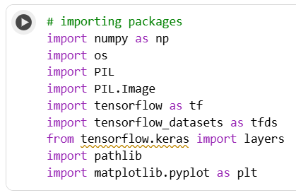

**Step 2**: Load the dataset 🡪 give path to access the data

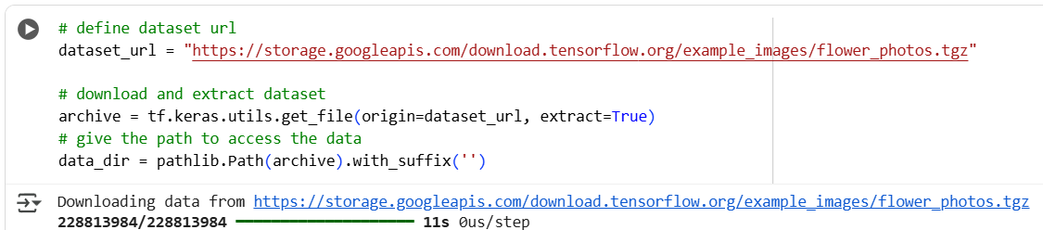

**Step 3**: Count the rose images and print it

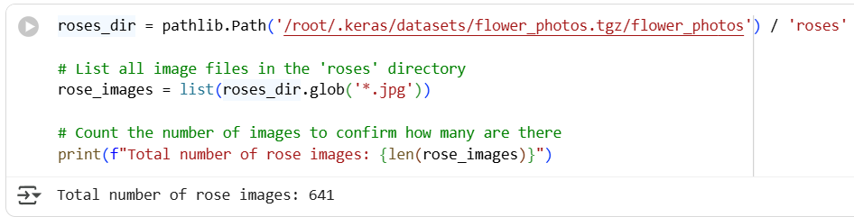

**Step 4:**  set all images of Roses in a list and display one

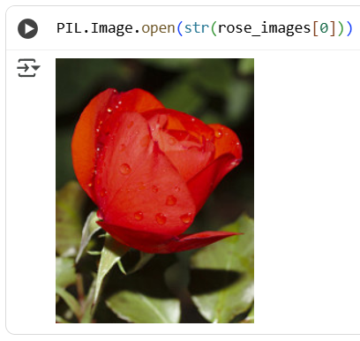

**Step 5**: Count the tulips images and print it

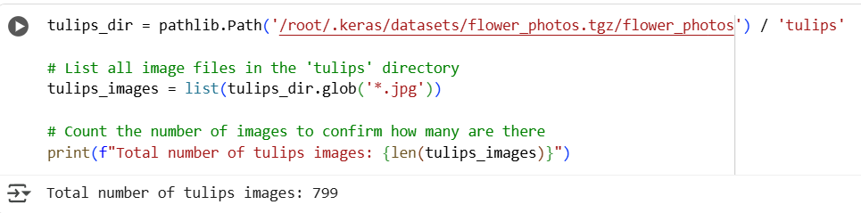

**Step 6:**  set all images of Tulips in a list and display one

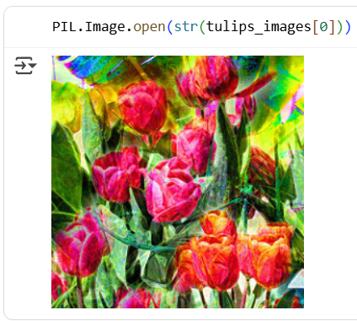

**Step 7:** Loadthe dataset

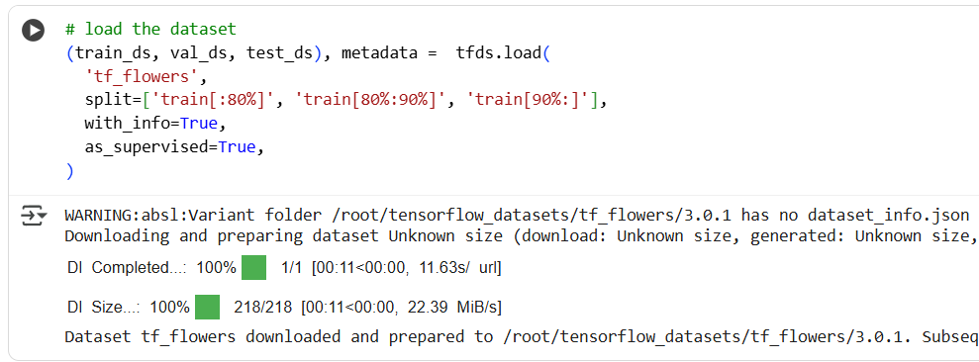

**Step 8:** Display image

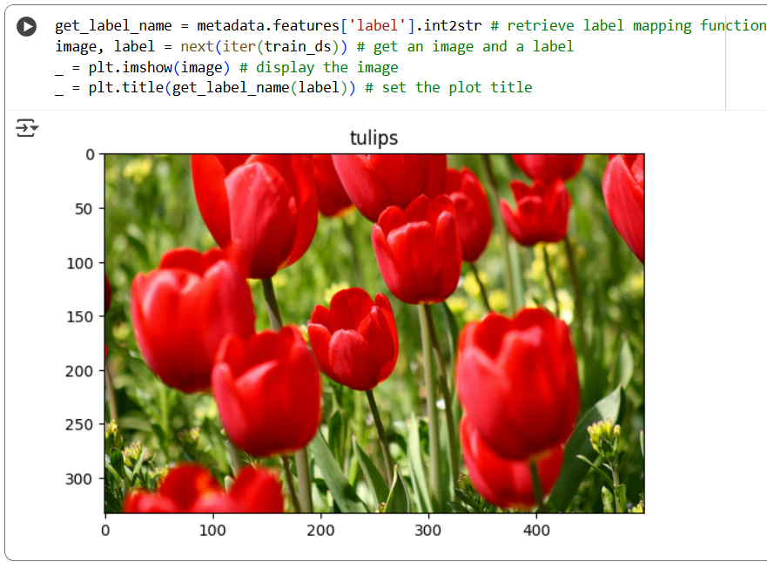

**Step 9:** Create sequential model for processing

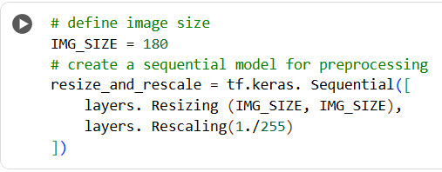

**Step 10:** Applying different image operation and display

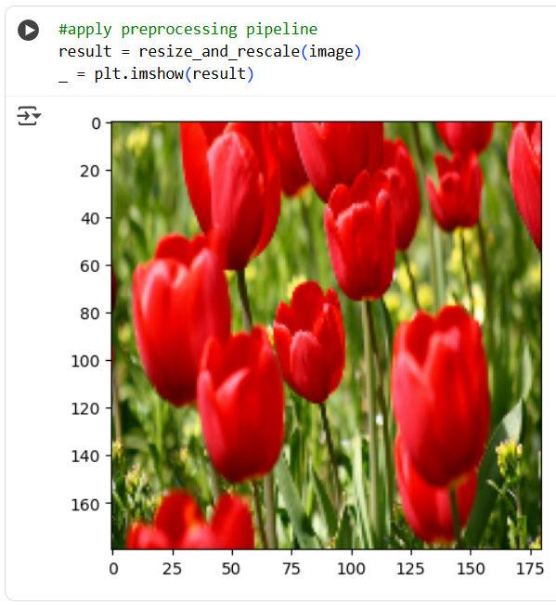

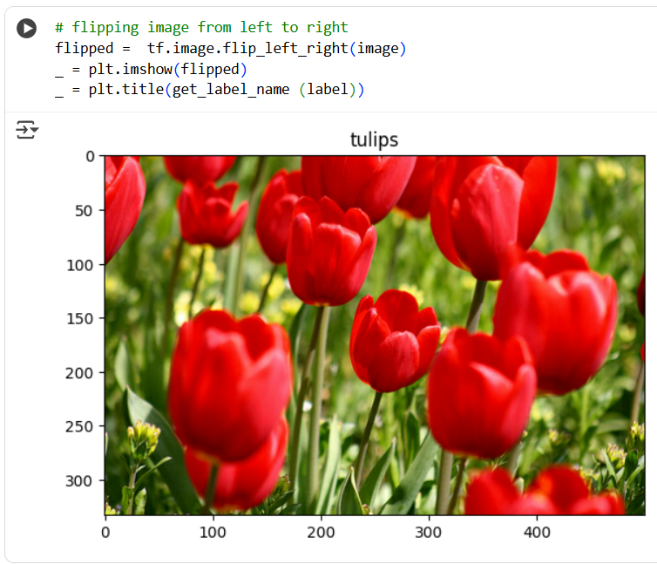

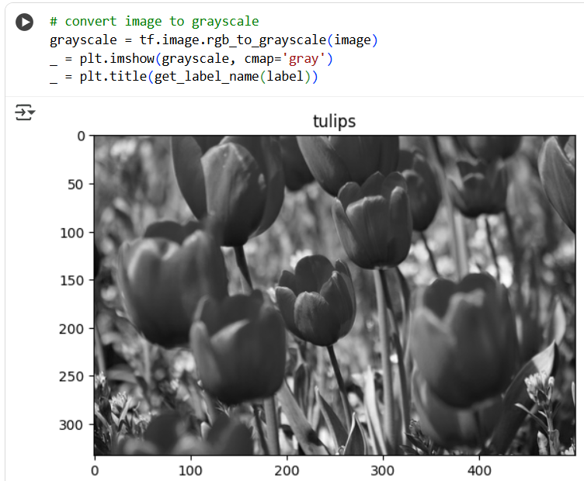

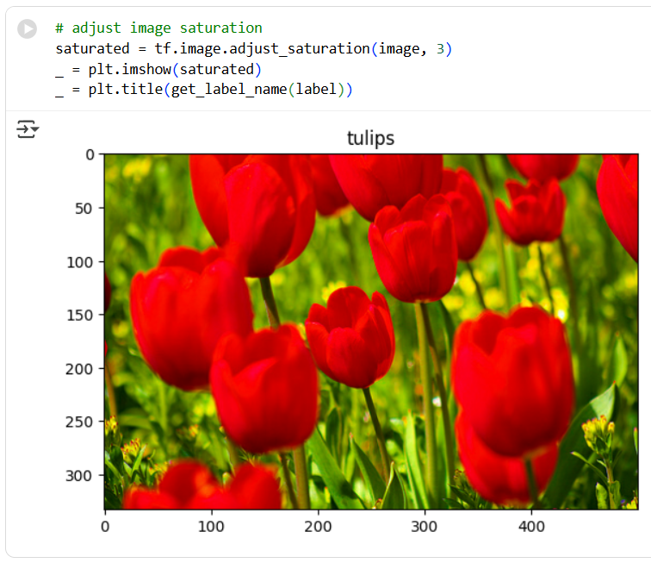

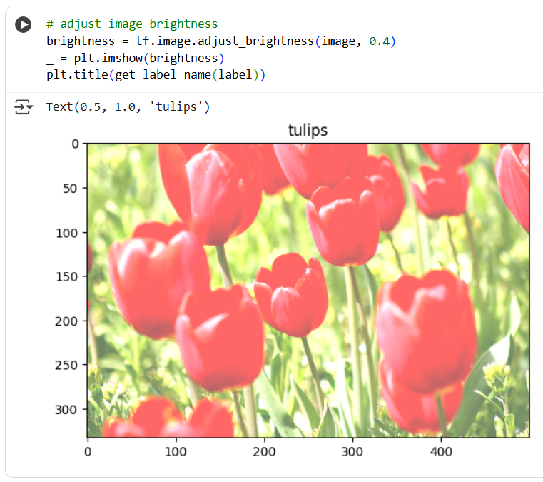

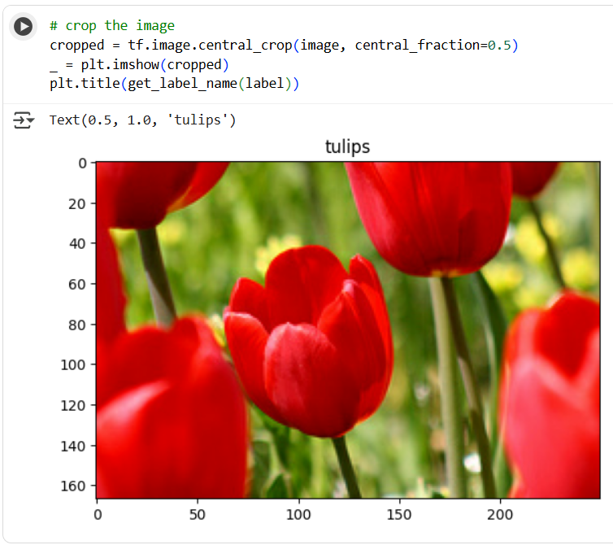

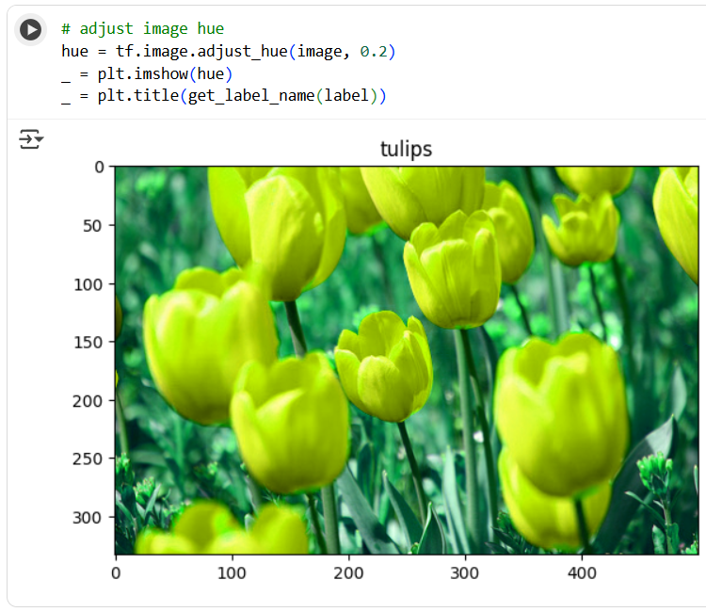

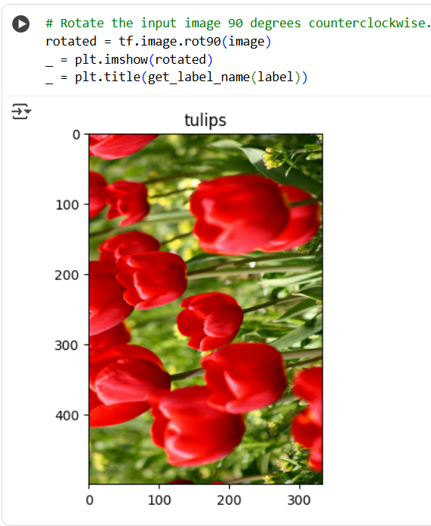

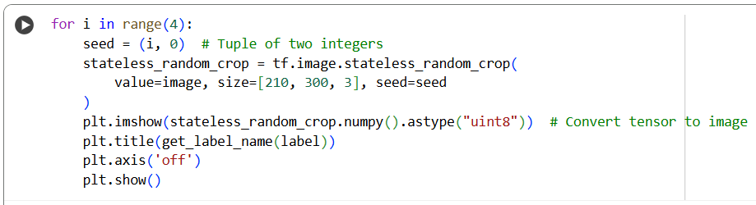

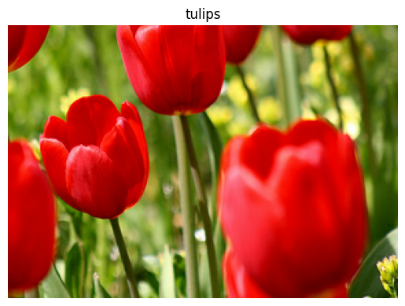 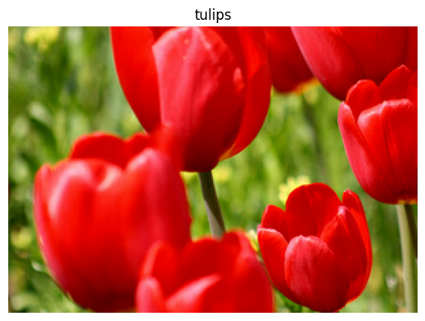

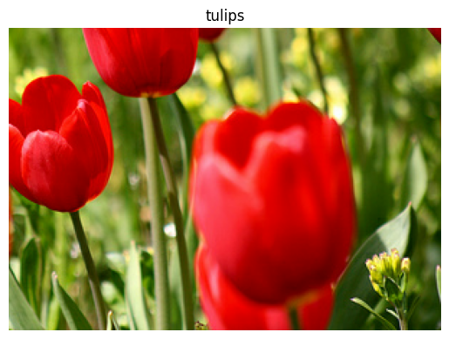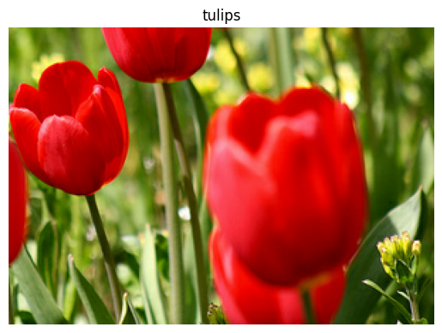

#### **Implement on a dataset**

Sep 20, 2025

**Step 1:** Importing necessary libraries.

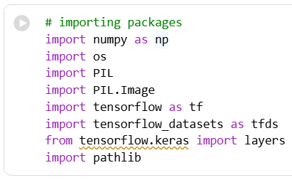

**Step 2:** Load the dataset from the URL.

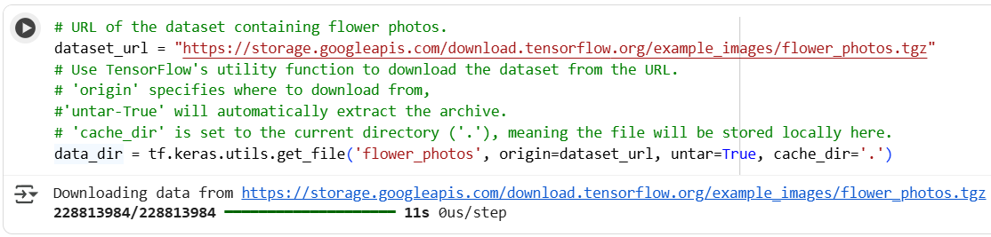

**Step 3:** Give the path where the datasetis downloaded

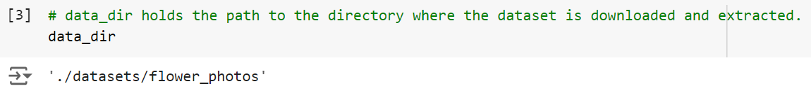

**Step 4:** Convert the dataset into pathlib path object

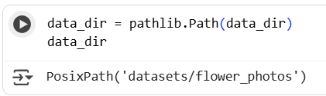

**Step 5: Listing** all the **.jpg files** within the **subdirectories** of **data_dir.**

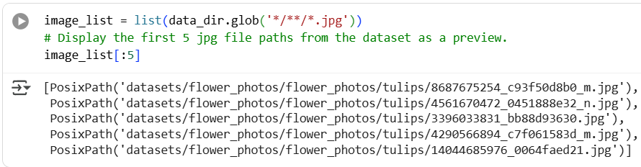

**Step 6:** Counting the total number of .jpg images in the subdirectories of data_dir

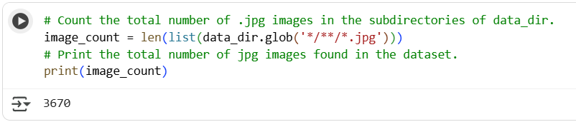

**Step 7:** Display paths of roses

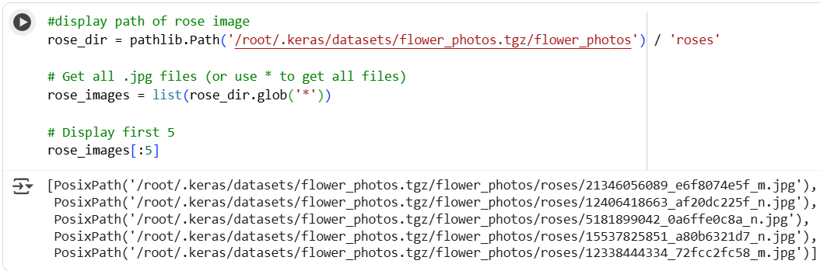

**Step 8:** Displaying Roses

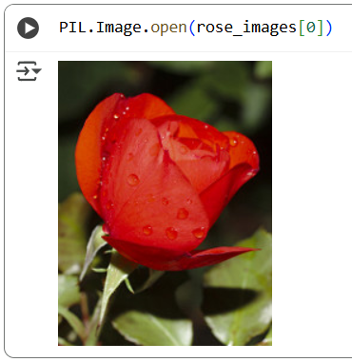

**Step 9:** Read the images from disk 🡪 creating dictionary for flower types to their corresponding numeric labels

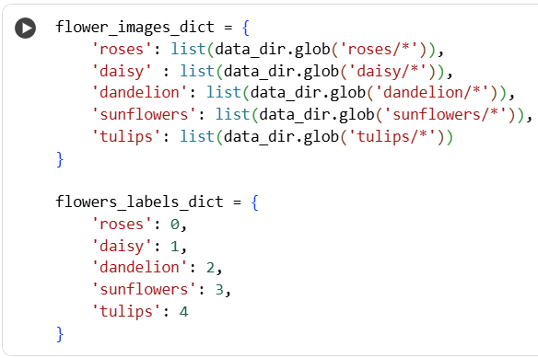

**Step 10:** Get the first 5 images path

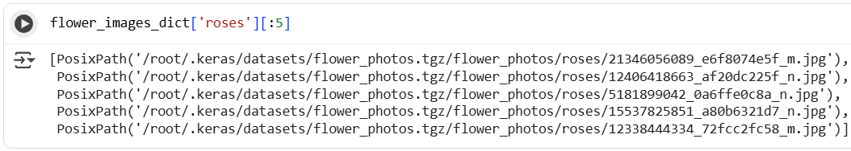

**Step 11:** Converting the path of the first image file in the 'roses' category to a string.

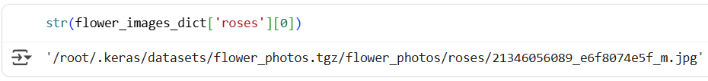

**Step 12:** Getting the image

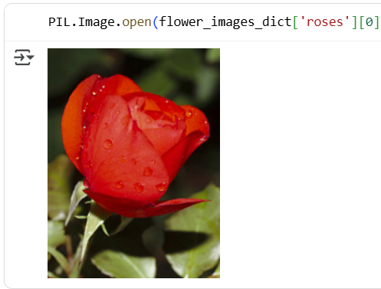

**Step 13:** Importing opencv library 🡪 reading the image

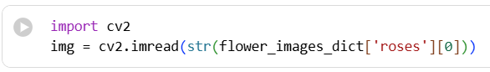

**Step 14:** Resize the image

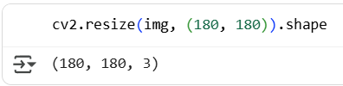

**Step 15:** Initialize and iterate

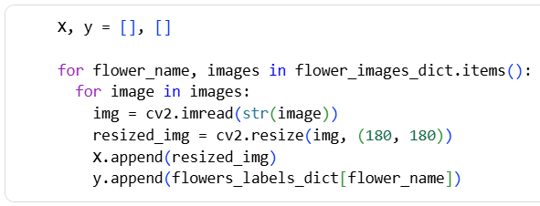

**Step 16:** Converting list of images to x and y arrays 🡪 getting the shape

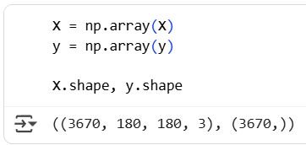

**Step 18:** Dividing data into training and testing sets

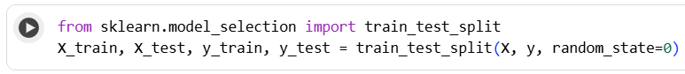

**Step 19: Scaling pixel values of both training and testing images**

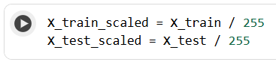

### **Practical 10: Implement RNN (Recurrent Neural Network)**

Sep 20, 2025

Date set link → <https://github.com/VikParuchuri/zero_to_gpt/blob/master/data/clean_weather.csv>

